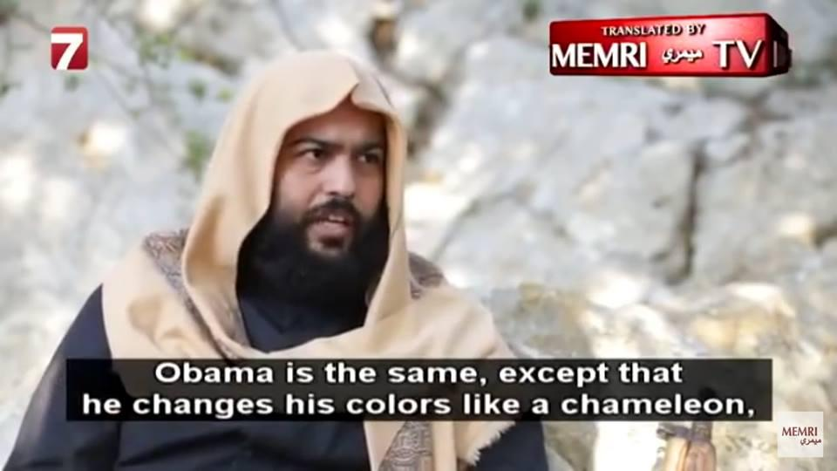

**TRANSLATED BY**

**N**

**| TV ميمري MEMRI**

**Obama is the same, except that he changes his colors like a chameleon,**

MEMRI

ميفري